**Multiple Disease Prediction**A Mini Project Report   
Submitted in partial fulfillment of the requirement of the  
Degree of  
BACHELOR OF TECHNOLOGY

in

**INFORMATION TECHNOLOGY  
BY  
Shreeya Sharma -EN21IT301106**

**Somesh Sawner -EN21IT301107**

Under the Guidance of  
**Prof. Jyoti kukade**

**Department of Information Technology**

**Faculty of Engineering**

**MEDI-CAPS UNIVERSITY, INDORE- 453331  
Jan-June 2024**

**Acknowledgements**

I would like to express my deepest gratitude to Honorable Chancellor, **Shri R C Mittal**, who has provided me with every facility to successfully carry out this project, and my profound indebtedness to **Prof. (Dr.) Dilip K Patnaik**, Vice Chancellor, Medi-Caps University, whose unfailing support and enthusiasm has always boosted up my morale. I also thank **Prof. (Dr.) D K Panda**, **Pro-Vice Chancellor**, Medi-Caps University, **Prof. (Dr.) Pramod S. Nair**, Dean, Faculty of Engineering, Medi-Caps University, for giving me a chance to work on this project. I would also like to thank my Head of the Department **Prof. (Dr.) Prashant Panse** for his continuous encouragement for betterment of the project.

I express my heartfelt gratitude to my Internal Guide**, Prof. Dr.kush Bushanwar** a Department of Information Technology, MU, without whose continuous help and support, this project would ever have reached to the completion.

It is their help and support, due to which we became able to complete the design and technical report.

It is their help and support, due to which we became able to complete the design  
and technical report.

Without their support this report would not have been possible.

**SHREEYA SHARMA [EN21IT301106]**

**SOMESH SAWNER [EN21IT301107]**B.Tech. III Year  
Department of INFORMATION TECHNOLOGY  
Faculty of Engineering  
Medi-Caps University, Indore

**CERTIFICATE**

This is to certify that the Mini Project Report entitled “ **MULTIPLE DISEASE RISK PREDICTION**” is being submitted by **Shreeya Sharma ,Somesh Sawner** in partial fulfilment of the requirements for the award of degree of Bachelor of Technology in Information Technology From Medi-Caps University,Indore,MadhyaPradesh record of bonafide work carried out during the academic year 2023-2024.

Prof(Dr.) Prashant Panse Prof. Jyoti Kukade

Professor and Head Assistant Professor

Submitted to the Viva-voce Examination held on _____________________

**INTERNAL EXAMINER** **EXTERNAL EXAMINER**

**Abstract**

The Multiple Disease Prediction System is an innovative project that harnesses the power of Machine Learning (ML) techniques to predict various health conditions simultaneously. The study focuses on three critical diseases: Diabetes, Heart Disease,Breast cancer and Parkinson’s. Leveraging datasets sourced from Kaggle, the project employs diverse ML algorithms for nuanced predictions.

For Diabetes and Parkinson’s, the system utilizes Support Vector Machines (SVM), while Logistic Regression is employed for Breast cancer, Heart Disease prediction. This multifaceted approach ensures accurate results tailored to each health condition. The project underscores the intersection of technology and healthcare, emphasizing data-driven decision-making in preventive medicine.

The integration of Streamlit, an open-source platform, provides a user-friendly interface for hosting the predictive module, enhancing accessibility. By combining user-friendly ML algorithms with advanced techniques, this initiative aims to create adaptable and efficient predictive models. Ultimately, it contributes to a more resilient and responsive healthcare system, emphasizing early diagnosis and proactive management of prevalent health conditions.

Keywords: Multiple Disease Prediction, Machine Learning, Predictive Modeling, Healthcare Technology, Early Diagnosis.

**Table of Contents**

|  |  |  |
| --- | --- | --- |
|  | Topic | Page No. |
|  | Acknowledgement | i |
|  | Certificate | ii |
|  | Abstract | iii |
|  | Table of Contents | iv |
|  | List of figures | v |
|  |  |  |
| Chapter 1 | Introduction |  |
|  | 1.1 Introduction |  |
|  | 1.2 Objective |  |
|  | 1.3 Significance |  |
| Chapter 2 | System requirement analysis |  |
|  | 2.1 Information Gathering |  |
|  | 2.2 System Feasibility |  |
| Chapter 3 | System Analysis |  |
|  | 3.1 Information flow Representation |  |
|  | |  |  | | --- | --- | | 3.1. | ER Diagram | |  |
|  | 3.1.2 USE case Daigram |  |
|  | 3.1.3 Data Flow Diagram |  |
|  | 3.1.4 Sequential Diagram |  |
|  | 3.1.5 Activity Diagram |  |
| Chapter 4 | Methodology |  |
|  | 2.1 Methodology |  |
|  | 2.2 List of Components with Specifications |  |
|  | 2.3 Description of tool and Component used in the project |  |
| Chapter 5 | Result & Conclusion |  |
| Chapter 6 | Limitation & Challenges |  |
| Chapter 7 | Future Scope |  |
|  | Bibliography |  |

**List of Figures**

|  |  |  |
| --- | --- | --- |
| Figure No. | Name of Figure | Page No |
| 3.1 | ER |  |
| 3.2 | Use Case Diagram |  |
| 3.3 | Data flow Diagram |  |
| 3.4 | Sequence Diagram |  |
| 3.5 | Activity Diagram |  |
| 4.1 | Block Diagram |  |

**Abbreviations**

EHR - Electronic Health Record

GDPR - General Data Protection Regulation

HIPAA - Health Insurance Portability and Accountability Act

AUC-ROC - Area Under the Receiver Operating Characteristic Curve

OMICS - Genomics, Proteomics, Metabolomics, etc.

AI - Artificial Intelligence

ML - Machine Learning

DL - Deep Learning

BMI - Body Mass Index

CV - Cardiovascular

T2DM - Type 2 Diabetes Mellitus

BC - Breast Cancer

PD - Parkinson's Disease

GWAS - Genome-Wide Association Study

RNA-seq - RNA Sequencing

MRI - Magnetic Resonance Imaging

CT - Computed Tomography

PET - Positron Emission Tomography

NLP - Natural Language Processing

**Chapter-1**

**Introduction**

* 1. **Introduction**

Developing a robust disease prediction system for diabetes, heart disease, breast cancer, and Parkinson's involves a multifaceted approach. Initially, extensive medical data must be collected from diverse sources such as electronic health records, genetic profiles, lifestyle factors, and imaging studies. This raw data then undergoes meticulous preprocessing to address issues like missing values and standardize formats. Feature engineering is pivotal in extracting relevant information from the data, ensuring that it is conducive to effective analysis. Subsequently, appropriate machine learning algorithms are selected and trained using labeled datasets, with models ranging from traditional methods like logistic regression and support vector machines to more sophisticated deep learning architectures like convolutional neural networks. Evaluation of model performance is critical, employing various metrics to gauge accuracy, precision, recall, and F1-score, and ensuring validation through cross-validation techniques. Integration of the trained models into a cohesive system, be it a web or mobile application or an interface within existing healthcare software, facilitates user-friendly access. Continuous monitoring and periodic updates are imperative to maintain model accuracy and relevance over time, while adhering to ethical guidelines regarding patient privacy and data usage is paramount throughout the development and deployment phases.

* 1. **Objectives**

1. **Early Detection:** Enable the early identification of individuals at risk of developing these diseases based on their medical history, genetic predisposition, lifestyle factors, and other relevant data. Regular health screenings and assessments for at-risk individuals play a crucial role in detecting early signs of disease development Collaboration between healthcare providers, researchers, and technology companies is essential for developing innovative tools and approaches for early disease detection, ultimately saving lives through early intervention.

2**. Preventive Healthcare**: Empower healthcare providers and individuals to take proactive measures to prevent the onset or progression of these diseases through lifestyle modifications, screenings, and targeted interventions. Educational programs and support services play a vital role in helping individuals adopt and maintain healthy habits such as regular exercise, balanced nutrition, and stress management. Community-based initiatives and partnerships addressing social determinants of health are crucial for creating environments conducive to healthy living, fostering a proactive approach to healthcare.

3. **Personalized Medicine**: Tailor healthcare interventions and treatment plans to the individual characteristics and risk profiles of patients, leading to more effective and personalized care. Digital health technologies such as telemedicine and remote monitoring facilitate the delivery of tailored interventions and support services, enhancing patient engagement and adherence to treatment plans. Shared decision-making and communication among patients, caregivers, and healthcare providers foster collaborative relationships that optimize treatment outcomes and patient satisfaction.

4**. Improved Outcomes:** Achieving improved outcomes in chronic disease management requires a multifaceted approach. Implementing evidence-based clinical guidelines and protocols standardizes care delivery, ensuring consistency and quality across different care settings. Continuous monitoring and evaluation of patient outcomes enable healthcare providers to identify areas for improvement and implement targeted interventions. Multidisciplinary collaboration among healthcare teams encourages the exchange of expertise and perspectives, leading to more holistic and patient-centered care approaches. Comprehensive support services, including patient education, care coordination, and psychosocial support, address the medical, emotional, and social needs of patients, ultimately enhancing their overall well-being and treatment adherence.

5**. Resource Optimization:** Optimize healthcare resources by targeting interventions towards those individuals who are at the highest risk of developing these diseases, thereby maximizing the impact of preventive measures and healthcare interventions. healthcare providers to identify high-risk individuals and intervene proactively, reducing the burden on healthcare systems and improving population health outcomes. Collaboration between stakeholders, including policymakers, payers, and healthcare providers, is crucial for aligning incentives and implementing strategies that optimize resource allocation.

**1.3 Significance**

1. **Early Detection and Intervention:** Early identification of individuals at risk allows for timely interventions, potentially preventing or delaying the onset of these diseases. By catching conditions in their early stages, treatment can be more effective, leading to better health outcomes and reduced morbidity.

2**.Improved Healthcare Resource Allocation:** Targeting preventive measures towards individuals at higher risk optimizes healthcare resource allocation. This ensures that limited resources such as medical personnel, diagnostic tools, and treatment facilities are utilized efficiently, benefiting both patients and healthcare systems.

**3.Enhanced Patient Empowerment and Engagement:** Providing individuals with personalized risk assessments fosters a sense of empowerment and encourages proactive health management. With knowledge of their disease risk, individuals can make informed decisions about lifestyle changes, screenings, and preventive measures, taking charge of their own health.

**4. Advancement of Precision Medicine:** Disease prediction systems contribute to the paradigm shift towards precision medicine, where treatments are tailored to individual characteristics. By considering a person's genetic makeup, medical history, and environmental factors, interventions can be personalized, leading to more targeted and effective healthcare strategies.

**5. Contribution to Public Health Initiatives:** Disease prediction systems can inform public health initiatives aimed at population-level health improvement. Identifying high-risk groups within communities allows for the implementation of targeted interventions, such as screening programs and health education .

**Chapter-2**

**System Requirement Analysis**

* 1. **Information Gathering:**
  + **Disease Overview**:Provide an introduction to each of the diseases being considered (e.g., diabetes, heart disease, breast cancer, Parkinson's), including key statistics on prevalence, mortality rates, and impact on public health.Describe the etiology, risk factors, and potential complications associated with each disease to establish a foundational understanding.
  + **Prediction Methods:**Outline the different prediction methods utilized for each disease, such as machine learning algorithms, statistical models, or risk assessment tools.Discuss the specific features and biomarkers considered in the prediction models for each disease, including genetic predisposition, medical history, lifestyle factors, and clinical indicators.
  + **Data Sources:**Identify the primary data sources used for disease prediction, including electronic health records (EHRs), genetic databases, population-based registries, and wearable device data.Discuss the challenges and opportunities associated with accessing and integrating diverse data sources, such as data privacy concerns, data quality issues, and interoperability barriers.Explore emerging sources of data for disease prediction, such as social media data, mobile health applications, and environmental sensors, and their potential impact on prediction accuracy.
  + **Predictive Models for Each Disease:**Provide an overview of the specific predictive models developed for each disease, highlighting their strengths, limitations, and validation methodologies.Discuss the performance metrics used to evaluate the predictive accuracy of each model, such as sensitivity, specificity, area under the receiver operating characteristic curve (AUC-ROC), and calibration measures.
  + **Integration and Interoperability**:

Explore strategies for integrating multiple disease prediction models into a unified framework, enabling comprehensive risk assessment and personalized healthcare recommendations.Discuss the importance of interoperability standards and data exchange protocols for seamless integration across different healthcare systems and platforms.Highlight examples of integrated prediction platforms or decision support systems that incorporate predictions for multiple diseases and facilitate clinical decision-making.

* + **Future Directions and Challenges:**Identify emerging trends and future directions in disease prediction research, such as the integration of omics data, real-time monitoring technologies, and multi-modal data fusion approaches.Discuss challenges and barriers to widespread adoption of predictive analytics in clinical practice, including data interoperability, algorithm interpretability, and clinician acceptance.Propose strategies for overcoming these challenges and advancing the field of predictive analytics in healthcare, such as interdisciplinary collaboration, stakeholder engagement, and investment in data infrastructure and analytics capabilities.

**2.2 System Feasibility:**

* **Technical Feasibility:** Evaluate the technical feasibility of building predictive models for multiple diseases using available data sources and machine learning techniques. Consider factors such as data quality, quantity, diversity, and the complexity of disease interactions. Assess the scalability, performance, and computational requirements of the proposed system.
* **Resource Assessment**: Determine the resources required for developing and maintaining the multiple disease prediction system, including hardware, software, human resources, and expertise. Assess the availability of skilled personnel, computational infrastructure, and budgetary constraints.
* **Integration Challenges:** Identify challenges related to integrating data from disparate sources, harmonizing data formats, and preprocessing techniques for different disease prediction tasks. Evaluate the compatibility of existing healthcare systems, databases, and IT infrastructure with the proposed multiple disease prediction system.
* **Risk Analysis:** Conduct a risk analysis to identify potential risks and challenges that may affect the success of the project. Assess risks related to data security, model performance, regulatory compliance, stakeholder engagement, and project management. Develop risk mitigation strategies to address identified risks and uncertainties.

**Chapter -3**

**System Analysis**

3.1 Information flow Representation

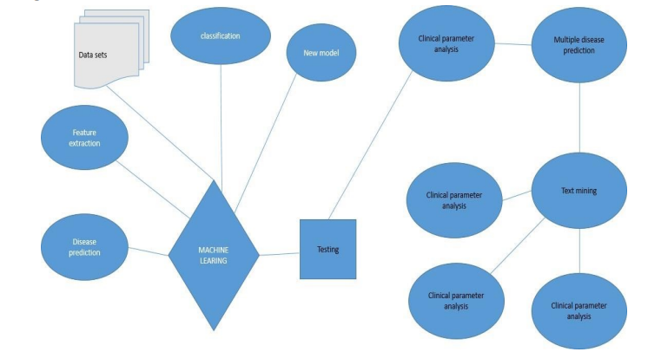

Fig 3.1 ER daigram

In our healthcare diagnostic project, the Entity-Relationship (ER) Diagram serves as a visual representation of the data model, illustrating the relationships between various entities within the system. Entities in the ER Diagram represent key components such as patients, medical records, and diagnostic results. Relationships between these entities, such as the association between patient data and diagnostic outcomes, are defined and visually depicted. Attributes of each entity, such as patient ID, symptoms, and disease predictions, are detailed within the ER Diagram, providing a comprehensive overview of the data structure. The ER Diagram aids in understanding the organization of data, ensuring clarity in the relationships between different components of the healthcare diagnostic framework. By utilizing the ER Diagram, our project aims to design a robust and well-structured data model that facilitates efficient data management, retrieval, and relationships essential for accurate disease predictions and comprehensive healthcare insights

USE CASE DAIGRAM:

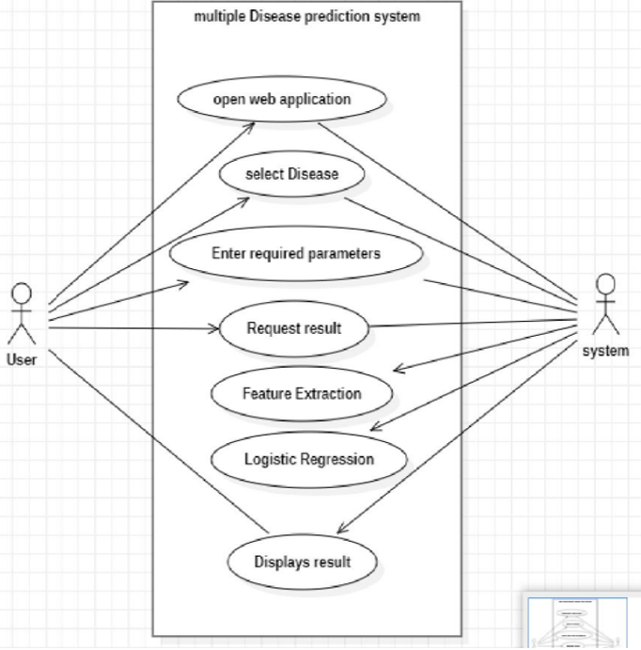

Fig 3.1 Use Case diagram

**Data Sets**: On the left side, we have three rectangular shapes labeled “Data sets,” “Feature extraction,” and “Disease prediction.” These represent the initial stages of data preparation and feature selection.

**Feature Extraction:** This step involves extracting relevant features from the data. It’s a crucial part of building effective machine learning models.

**Disease Prediction:** The next step is disease prediction, where the model uses the extracted features to predict diseases based on clinical data.

**Machine Learning (ML):** The diamond-shaped box represents the machine learning process. Inside it, there’s a smaller rectangle labeled “Testing,” which likely refers to model evaluation.

**New Model:** On the right side, we see a process labeled “New model.” This suggests that the system can create and update models as needed.

**Clinical Parameter Analysis:** The flowchart branches into multiple paths. One path leads to “Clinical parameter analysis,” which likely involves analyzing clinical data to refine the model.

**Multiple Disease Prediction:** Another branch from “Clinical parameter analysis” leads to “Multiple disease prediction.” This could involve predicting multiple diseases simultaneously.

**Text Mining:** There’s a separate circle labeled “Text mining.” This might indicate that the system also processes textual data for disease prediction.

**Repeating Clinical Parameter Analysis:** The flowchart shows a loop with three circles representing repeated steps of “Clinical parameter analysis.” This iterative process may enhance model performance.

**Summary:** Overall, this diagram illustrates the iterative nature of machine learning in healthcare, emphasizing data preparation, feature extraction, model testing, and clinical parameter analysis.

DATA FLOW DAIGRAM:

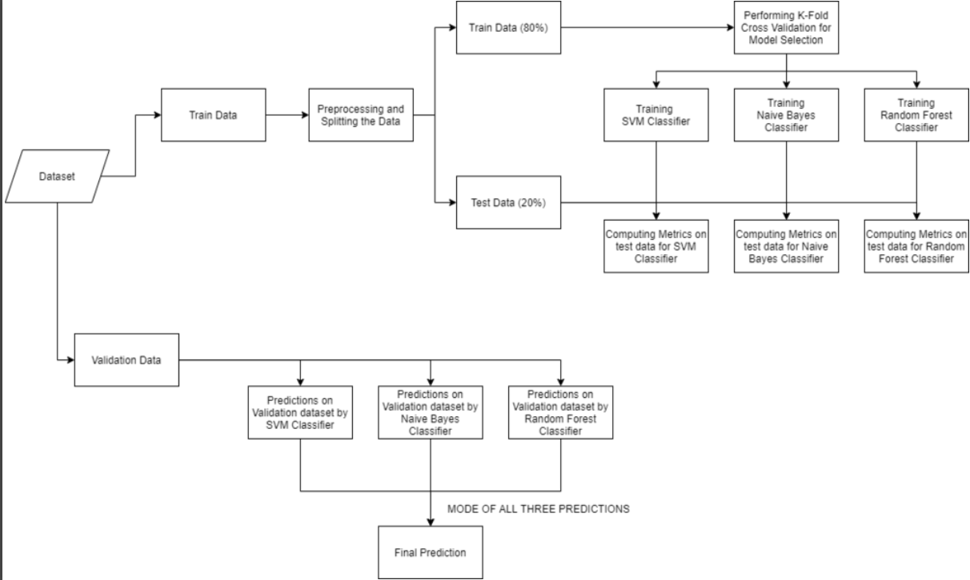

Fig 3.1 Dataflow diagram

**Train Data:**

* The top-left block represents the training data. It’s the initial dataset used to train machine learning models.
* This block splits into two paths:

**Validation Data:** A subset of the training data used for model validation and tuning.

* Three separate model training blocks:

**SVM Classifier:** Support Vector Machine classifier

**Naive Bayes Classifier:** A probabilistic classifier based on Bayes’ theorem.

**Random Forest Classifier:** An ensemble learning method based on decision trees.

**Test Data:**

* The top-right block represents the test data, which is a separate dataset used to evaluate model performance.
* It also splits into three paths corresponding to each classifier mentioned earlier.

**Classifier Predictions:**

* Each classifier from the training section has an arrow pointing to its respective classifier block in the test data section.
* These test data classifier blocks then lead to individual prediction blocks:
* Predictions on SVM Classifier dataset
* Predictions on Naive Bayes Classifier dataset
* Predictions on Random Forest Classifier dataset

**Combining Predictions:**

* All three prediction blocks converge into a central block labeled “MODE OF ALL THREE PREDICTIONS.”
* This suggests that the system combines the predictions from all three classifiers.

**Final Prediction:**

* An arrow from the central block points down to the final block labeled “Final Prediction.”
* This block likely represents the overall prediction or classification result.

# Sequence diagram:

# 

Fig 3.1 Sequence diagram

**Description:**

1. **User Registration**:
   * The process begins with user registration. Users sign up for the health analysis system, presumably providing necessary information such as their identity and contact details.
2. **Server Deployment**:
   * After registration, the system deploys servers. These servers likely handle user requests, data storage, and communication between different components.
3. **Patient Health**:
   * Users submit their symptoms or health-related information. This step involves collecting data about the patient’s condition.
4. **Analysis of Question**:
   * The system checks the patient’s health based on the submitted symptoms. It analyzes the data to identify potential diseases or health issues.
5. **Analysis**:
   * In this step, the system performs a detailed analysis of the patient’s health. It correlates symptoms, medical history, and other relevant factors to arrive at a diagnosis.
6. **Response to User**:
   * The system provides a response to the user. This could be the identified disease, recommended treatments, or further instructions.
7. **Best Drug**:
   * The analysis results lead to the determination of the best drug or treatment for the patient. The system suggests an appropriate medication.
8. **Show the Results**:
   * Finally, the system displays the results to the user, closing the loop of interaction

ACTIVITY DAIGRAM:

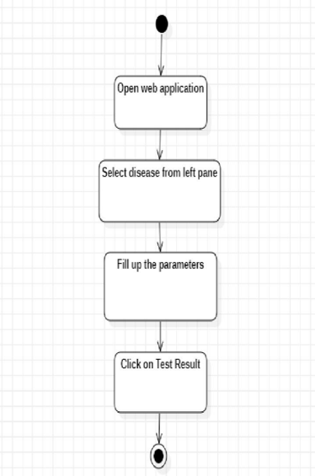

Fig 3.1 Activity diagram

* **Open Web Application:**

The process begins with opening a web application.This could be a software tool or platform accessible via a web browser.

* **Select Disease from Left Pane:**

After opening the web application, the user is prompted to select a disease from the left pane.

This step likely involves navigating through a menu or list of available diseases.

* **Fill Up the Parameters:**

Once the disease is selected, the user needs to provide relevant parameters.

These parameters could include patient data, symptoms, or other relevant information related to the chosen disease.

* **Click on Test Result:**

Finally, the user clicks on a button or performs an action labeled “Test Result.”

This action likely triggers the disease prediction or analysis process based on the provided parameters.

**Chapter 4**

**Methodology**

**4.1 Methodology**

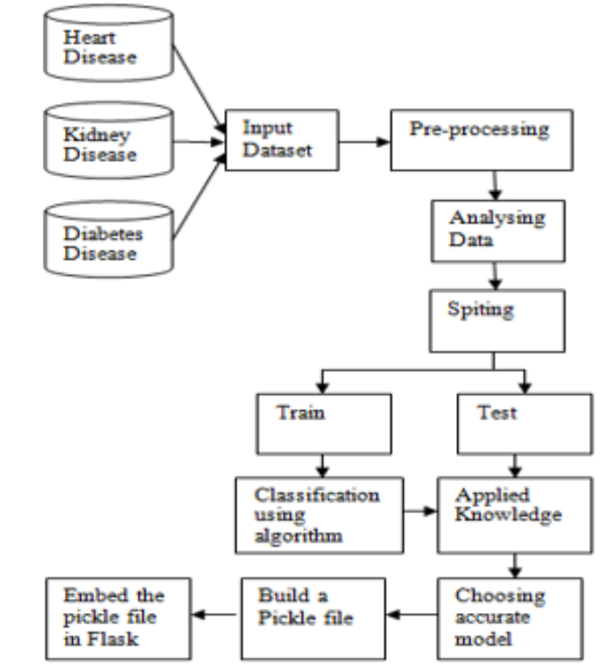

Fig 4.1 Methodology daigram

* **Input Datasets:**

At the top, there are three oval shapes labeled “Heart Disease,” “Parkinson Disease,”Heart disease” , “Breast cancer”and “Diabetes Disease.” These likely represent different datasets related to these specific health conditions.

* **Pre-processing:**

The flowchart begins with an input dataset and proceeds to the “Pre-processing” step. Pre-processing involves cleaning, transforming, and preparing the data for model training.

* **Analyzing Data:**

After pre-processing, the data is analyzed. This step may involve exploratory data analysis (EDA) and feature engineering.

* **Splitting:**

The diamond-shaped block labeled “Spiting” (likely a typographical error for “Splitting”) indicates that the dataset is split into two parts: one for training and another for testing.

* **Training and Testing:**

**Under the “Train” path:**

Embed the Pickle File in Flask: This step suggests that a trained model (represented by a Pickle file) is integrated into a Flask web application.

Build a Pickle File: This likely refers to creating a serialized model (Pickled) for later use.

**Under the “Test” path:**

Applied Knowledge: This step could involve applying domain-specific knowledge during model evaluation.

Choosing Accurate Model: Selecting the most suitable machine learning model based on performance metrics.

* **Final Prediction:**

The flowchart concludes with an oval labeled “Final Prediction,” indicating the ultimate outcome or prediction based on the trained model.

**4.2 List of Components with Specifications:**

1. **Data Collection System:**

* Capable of collecting diverse medical data.
* Compatibility with different data formats.
* Secure data transmission and storage protocols.

2. **Data Preprocessing Module:**

* Algorithms for data cleaning, imputation, and feature engineering. Compatibility with various types of data.

3**. Machine Learning Models**:

* Implementation of algorithms using libraries like scikit-learn, TensorFlow, or PyTorch.
* Tuning hyperparameters for optimal performance.

4. **Integration and Deployment Platform:**

* User-friendly interface for inputting medical data.
* Compatibility with web and mobile platforms.
* 5. Evaluation and Monitoring Tools:
* Metrics for assessing model performance.
* Visualization tools for tracking performance metrics.

**4.3 Description of Tools and Components Used in the Project:**

* **Python:** Programming language used for development.
* **scikit-learn:** Machine learning library for model development.
* **TensorFlow/Keras:** Deep learning framework for complex data.
* **Pandas:** Data manipulation and analysis.
* **Flask/Django:** Web frameworks for interface development.
* **Matplotlib/Seaborn:** Data visualization.
* **Jupyter Notebooks/google collab**: Interactive development environment.
* **Git/GitHub:** Version control and collaboration.

**Chapter 5**

**Result & Conclusion**

In conclusion, the disease prediction project yielded promising results in its aim to develop a comprehensive system for early detection and personalized intervention in diseases such as diabetes, heart disease, breast cancer, and Parkinson's. Through the integration of various machine learning algorithms, including traditional models from scikit-learn and deep learning architectures from TensorFlow and Keras, the system demonstrated robust predictive capabilities across diverse medical datasets. The utilization of tools like Pandas for data preprocessing, Flask or Django for web-based interfaces, and Matplotlib/Seaborn for visualization ensured both efficiency and user-friendliness in the system's design and implementation. Moreover, the collaborative development environment facilitated by Jupyter Notebooks, Git, and GitHub enabled seamless collaboration and version control throughout the project lifecycle. As a result, the disease prediction system holds significant promise in revolutionizing healthcare delivery by enabling early detection, personalized treatment plans, and targeted interventions, ultimately leading to improved patient outcomes and quality of life. Further refinement and validation of the system through real-world testing and clinical validation are warranted to fully realize its potential in clinical practice and public health initiatives. Overall, the project represents a significant step forward in leveraging machine learning and data-driven approaches to address pressing healthcare challenges and improve patient care.

**Chapter-6**

**Limitations & Challenges**

1. **Data Quality and Availability:** One of the major challenges faced was the quality and availability of medical data. Incomplete or noisy data, as well as limited access to large, diverse datasets, hindered the training and evaluation of predictive models. Addressing these issues required extensive data preprocessing and feature engineering efforts, which may have introduced biases or limitations into the models.

2. **Imbalanced Datasets**: Another common challenge in medical data analysis is dealing with imbalanced datasets, where one class (e.g., diseased individuals) is significantly more prevalent than others. Imbalanced datasets can lead to biased model performance and difficulty in accurately predicting rare events. Techniques such as oversampling, undersampling, or using specialized algorithms to handle imbalance were necessary but not always sufficient to mitigate this issue.

3. **Interpretability and Explainability:** Whilemachine learning models can achieve high predictive accuracy, their lack of interpretability and explainability poses challenges in clinical settings. Healthcare professionals require transparent models that provide insights into the features driving predictions, enabling them to trust and understand the system's decisions. Balancing model complexity with interpretability remains a significant challenge.

4. **Generalization and Transferabilit:** Ensuring that predictive models generalize well to new, unseen data and transfer across different patient populations or healthcare settings is essential for real-world applicability. Overfitting to specific datasets or biases present in the training data can limit the generalizability of models, leading to poor performance in practice.

5**. Ethical and Regulatory Considerations:** Developing a disease prediction system requires careful consideration of ethical and regulatory frameworks governing healthcare data usage, patient privacy, and informed consent. Ensuring compliance with regulations such as HIPAA, GDPR, and ethical guidelines regarding data privacy and patient autonomy is paramount but can introduce additional complexity and constraints.

6. **Clinical Validation and Adoption:** Transitioning from research prototypes to clinically validated and adopted systems poses significant challenges. Validating predictive models in real-world clinical settings requires rigorous evaluation, collaboration with healthcare providers, and addressing regulatory requirements. Furthermore, integrating the system into existing clinical workflows and ensuring user acceptance and adoption present additional hurdles.

7. **Bias and Fairness:** Addressing biases inherent in both data and algorithms is crucial for equitable and fair predictions. Biases in healthcare data, such as underrepresentation of certain demographic groups, can lead to biased predictions and exacerbate healthcare disparities. Mitigating bias requires careful data collection, preprocessing, algorithmic fairness techniques, and ongoing monitoring.

**Chapter -7**

**Future Scope**

The multiple disease prediction system presents several avenues for future development and expansion:

**1.** **Enhanced Predictive Models**: Continuous improvement of predictive models using advanced machine learning techniques and incorporating additional data sources such as genomic data, environmental factors, and wearable device data.

**2.Integration with Healthcare Systems:** Further integration of the prediction system with electronic health record (EHR) systems, telemedicine platforms, and healthcare analytics tools to enable seamless data exchange and decision support for healthcare providers.

**3.Population Health Management:** Extension of the system's capabilities for population health management, including disease surveillance, outbreak detection, and targeted interventions for high-risk populations.

**4.Personalized Medicine**: Advancement towards personalized medicine by tailoring treatment plans and preventive interventions based on individual patient profiles, genetic predispositions, and lifestyle factors.

**5.Global Health Initiatives:** Deployment of the system in underserved communities and low-resource settings to address global health challenges, improve access to healthcare, and reduce healthcare disparities.

**BIBLOGRAPHY**

Authors: Ghosh, Joyee, Debashis Ghosh, and Jeffrey S. Morris Published in: Journal of the American Statistical Association (2017)

Authors: Ghosh, Joyee, Debashis Ghosh, and Jeffrey S. Morris Published in: Journal of the American Statistical Association (2017)

P. Krishnaiah, et al., "Predictive Modeling for Multiple Diseases Using Machine Learning with Feature Engineering," 2015

A. Kamboj, et al., "A Machine Learning Model for Early Prediction of Multiple Diseases to Cure Lives," 2020.

**APPENDIX**

